**Air Pollution Monitoring System using MQ135 Sensor**

Introduction

Day to day, the level of Air pollution is increasing rapidly due to increase industries, factories, vehicle use which affect human health. So here we have designed a device/system which can measure air quality around it and monitor air pollution levels and also indicates and warns us when the air quality goes down beyond a certain level. This system can sense NH3, NOx, alcohol, Benzene, smoke, CO2, and some other gases

The gas sensor continuously measures air quality and sends data to the Arduino board. Then Arduino prints air quality value on the OLED display in the PPM unit. The LEDs and Buzzer used as indicators, that indicates the air quality is in good, Poor, or dangerous zone.

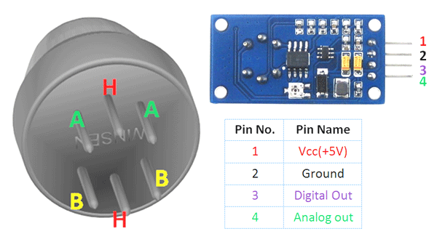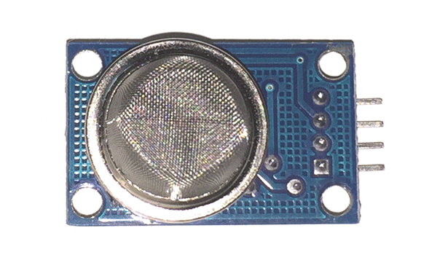

Components

MQ135 gas sensor

Arduino nano board ,

Red LED 2

16*2 LCD display

Buzzer

220 ohm resistor

Connecting wires

9v battery with connector

Application

* Used to detect leakage/excess of gases like Ammonia, nitrogen oxide, alcohols, aromatic compounds, sulfide and smoke.
* Air quality monitors.

Objective

During this activity ,you will help students to achieve following objectives

1. Understanding the principle and operation of MQ-135 sensor as gas detector
2. Design algorithm and flowchart to detect gases such as NH3, NOx, alcohol, Benzene, smoke, CO2,
3. Programming MQ-135 Sensor module using Arduino uno
4. Interfacing MQ-135 Sensor module withArduino uno

Programming steps

1. Include LCD display libraries
2. Include libraries for MQ-135 Sensor
3. Define ports for LCD display
4. Define ports for Green , red LED and buzzer
5. Initialize setup as both LED and buzzer as output
6. Initilase sensore input as smokeinput as A0
7. Read analog input value of sensor.
8. Check if analog sensor value is greater than threshold ,then LED 1 gets on and buzzer sounds,display message on LCD(‘ALERT’)
9. Else display on LCD(‘NORMAL’) and LED 2 on ,buzzer off.

Program

|  |
| --- |
| #include <LiquidCrystal.h>  LiquidCrystal lcd(7, 6, 5, 4, 3, 2);    int redLed = 10;  int greenLed = 12;  int buzzer = 8;  int smokeA0 = A0;  // Your threshold value  int sensorThres = 100;    void setup() {    pinMode(redLed, OUTPUT);    pinMode(buzzer, OUTPUT);    pinMode(smokeA0, INPUT);    Serial.begin(9600);    lcd.begin(16,2);  }    void loop() {    int analogSensor = analogRead(smokeA0);      Serial.print("Pin A0: ");    Serial.println(analogSensor);    lcd.print("Smoke Level:");    lcd.print(analogSensor-50);    // Checks if it has reached the threshold value    if (analogSensor-50 > sensorThres)    {      digitalWrite(redLed, HIGH);      lcd.setCursor(0, 2);      lcd.print("Alert....!!!");      digitalWrite(12, LOW);      tone(buzzer, 1000, 200);    }    else    {      digitalWrite(redLed, LOW);      digitalWrite(12, HIGH);      lcd.setCursor(0, 2);      lcd.print(".....Normal.....");      noTone(buzzer);    }    delay(500);    lcd.clear();  } |

Hardware

Instructions

Make connection as per following

LCD Pins **1, 3 ,5 ,16** ——— **GND**  
LCD Pins **2, 16** ————— **VCC**(+5V)  
LCD Pin **4** —————— – Arduino pin **D7**  
LCD Pin **6** —————— – Arduino pin **D6**  
LCD Pin **11** ——————- Arduino pin **D5**  
LCD Pin **12** ——————- Arduino pin**D4**  
LCD Pin **13** ——————- Arduino pin **D3**  
LCD Pin **14** ——————- Arduino pin **D2**  
MQ-135 Module Pin **-GND** —— **GND**  
MQ-135 Module Pin **+VCC** —— **VCC**  
MQ-135 Module Pin **A0** — Arduino Pin **A0**  
LED1 Pin +ve end ————- Arduino Pin**D10**  
LED1 Pin -ve end ————-**GND**

LED2 Pin +ve end ————- Arduino Pin**D12**  
LED2 Pin -ve end ————-**GND**

Buzzer Pin +ve end ————- Arduino Pin**D8**  
Buzzer Pin -ve end ————-**GND**

